**Lab 4: FORCE EVALUATION**

***Amari West, Gabe Moreno, James Kan, Luke Morgan***

**Texas A&M University**

College Station, TX 77843, US.

***Abstract*** *This lab report details the two main variables of friction in forces. With the tracking camera, the position, velocity, and acceleration can be detected in order to compute the angles of numerous forces so that models and expressions for these forces can be derived to solve coefficients of static and kinetic friction – including their dependencies on the surface area of contact and resulting uncertainties*

***Keywords:*** *friction, static, kinetic*

1. **Introduction**

As an object slides down an incline, components of gravity and the normal force accelerate the object down the incline. Friction is a force that acts perpendicular to the motion of the object or in resistance to an object starting to move. In this lab, the concept of static friction and kinetic friction were explored. The goal of the lab was to experimentally determine the static and kinetic coefficients of friction for rubber and wood by utilizing an adjustable incline. In order to be able to calculate the coefficients of friction based on data obtained from a camera, the gravitational force, normal force, and the friction force were analyzed. The net acceleration of the object can be captured using a camera system. From this data, the force of kinetic friction can be calculated using Newton’s Laws. Static friction is the force that must be overcome in order to initiate the sliding of one object on another. Static friction cannot cause a net acceleration in an object and instead exerts a force equaling the applied force on an object up to a certain point. Therefore, in order to find the maximum force exerted by static friction, the angle of the incline can be slowly raised until the block starts to slide. Once the maximum angle that static friction is able to prevent the object from moving is found, the coefficient of static friction can be calculated again using Newton’s Laws.

1. **Experimental Procedure** (see [here](https://tamu.blackboard.com/bbcswebdav/pid-6578715-dt-content-rid-59557859_1/courses/ENGR.216.2011.M4/216_lab4.pdf) for complete and specific instructions)

To find coefficients of static friction, the angle of the ramp was gradually adjusted with the block by letting go of the block after each micro-adjustment from the top of the ramp. If the block was observed to maintain a consistent nonzero velocity during its travel down the ramp after an adjustment, then the angle was derived with trigonometry from the vertical length of the ramp from the top and the constant length of the ramp (the hypotenuse).

To find the coefficients of the kinetic friction, the angle of the ramp was increased to a point where the block could slide down with ease. A camera was positioned to capture video of the block sliding down from the side perspective of the ramp. A program would then take the captured data and generate a .csv file containing the block’s motion and position. In order to accurately record data, the block slid down the ramp on 4 of its sides for a total of 9 trials per side. After each trial, the data was recorded and stored in the appropriate folder for further analysis. Of the sides tested, two were coated with rubber while the other two had an exposed wooden surface.

1. **Results and Analysis**

The following coefficients for each surface were calculated from both vertical and horizontal net force equations. The angle $α$ indicates the angle of the ramp from the horizontal, and $ϕ$ indicates the complementary angle of $α$, which is the angle of the normal force from the horizontal.

**Wood, large and small (respectively):**

$$u_{sy}= \frac{1 - \sin{ϕ}}{\sin{α}}= 0.150807 (δu_{s}=0.16); u_{sx}=\frac{\cos{ϕ}}{\cos{α}}=0.308634$$

$$u_{sy}=0.16416 (δu_{s}=0.17325); u_{sx}=0.3374$$

**Rubber, large and small (respectively):**

$$u_{sy}=0.228468 (δu_{s}=0.25); u_{sx}=0.482100$$

$$u_{sy}=0.3764 (δu_{s}=0.48826); u_{sx}=0.85869$$

To calculate kinetic friction, first, a free body diagram of the wooden block was drawn to illustrate the forces acting on the block throughout all trials.

Figure 1: Diagram of wooden block on the inclined plane

Using Newton’s Second law, the following formula was derived to calculate the coefficient of kinetic friction for each surface of the block.

$ΣF_{x}=ma_{x}=μmgcosθ-mgsinθ$***Equation 1***

$μ_{k}= \frac{a_{x}}{gcos(θ)}+tan(θ)$ Equation 2

The angle, $θ$, was found to be 37.24 degrees using inverse tangent of the opposite over the adjacent lengths of the ramp , the average acceleration vector for each of the 4 faces were calculated along with their uncertainty via standard deviation of the mean (as shown below), using the data from each trial. Some data was excluded from the mean calculation, however, due to the fact that it reflected the moments before the block was released as well as the moments after.

$σ_{\overline{x}}=σ_{x}/\sqrt{N}$***Equation 3***

The friction dependence on surface area also needed to be determined. This question was answered through placing the rectangular prism shaped object on its large sides (one rubber, one wood) and small sides (one rubber, one wood), then comparing the values of both kinetic and static frictions along these sides. For example, the value of the kinetic friction of the small side would be compared to the kinetic friction of the large side. Once the two separate values of friction were calculated, it was time to determine if the friction values depended on which surface area was used.

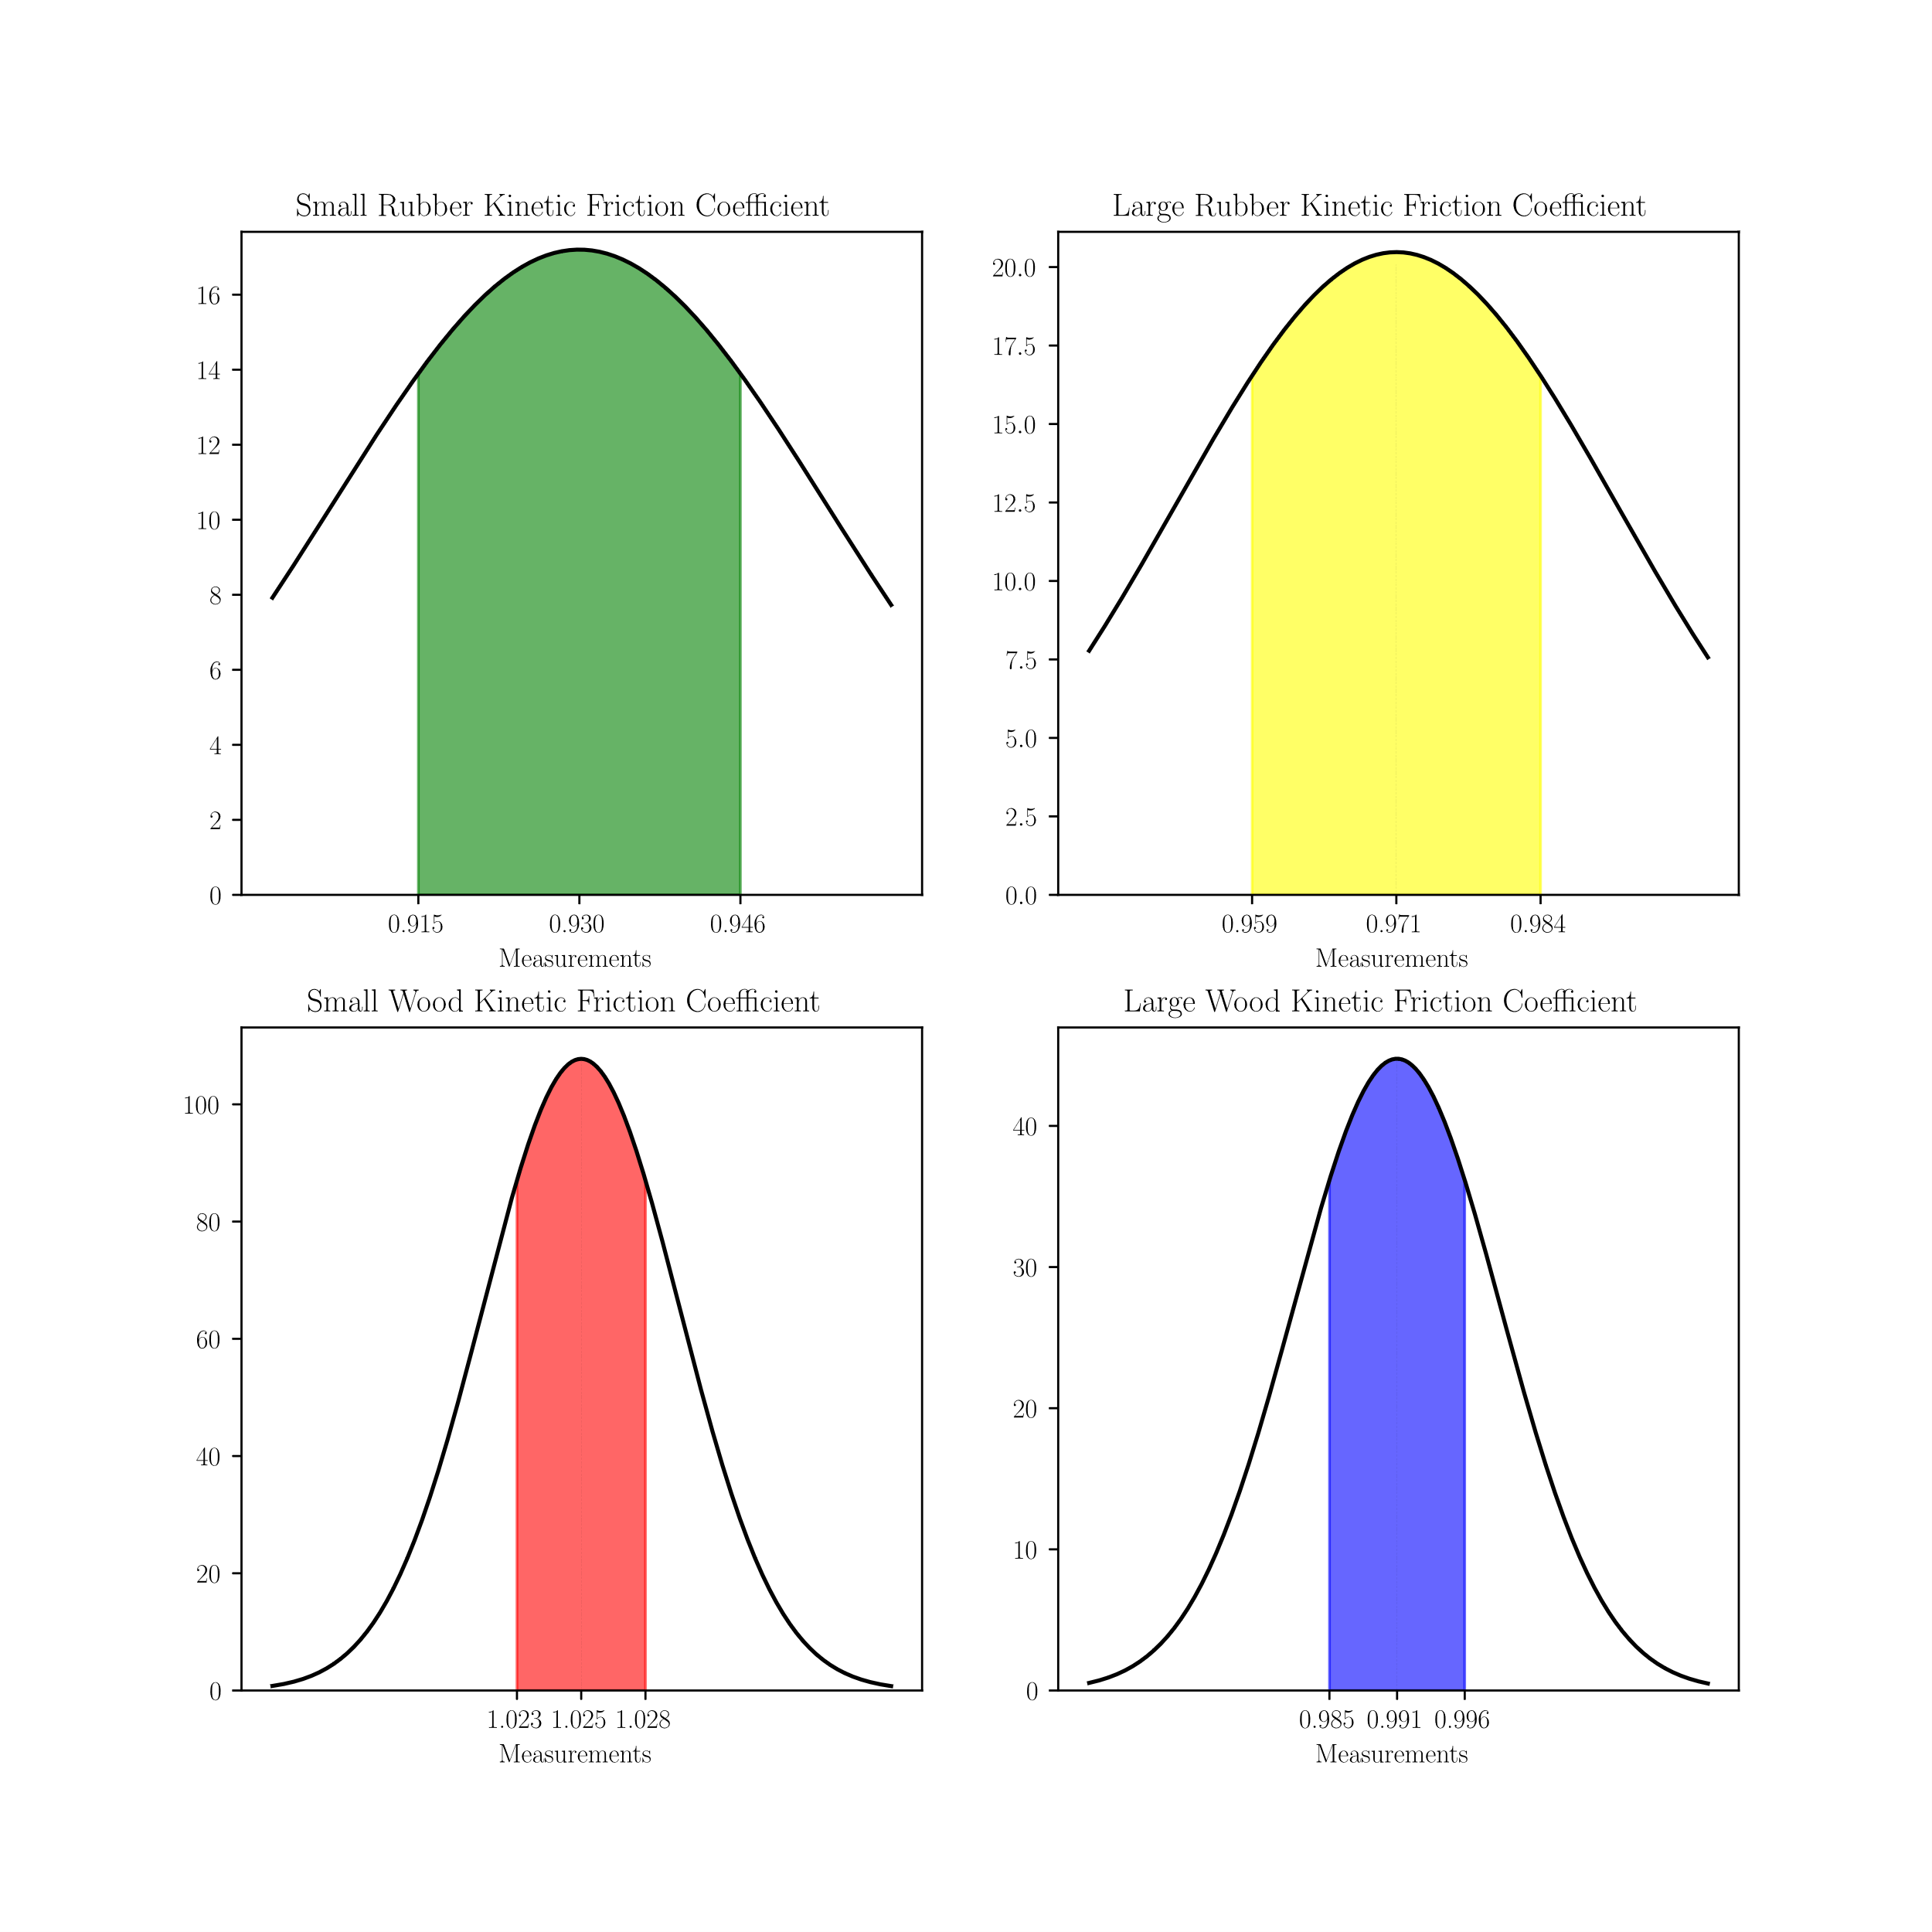

Figure 2: Illustration of Confidence Intervals of Kinetic Friction Coefficient

For the kinetic friction, the value of the rubber was 0.930382 ± 0.023192 for the small side and 0.971411 ± 0.019483 for the large side; the 95% confidence intervals for the coefficient of friction values were (0.9152, 0.9455) for the small side and (0.9587, 0.941) for the larger side.   
  
The kinetic friction of the wood had 1.025301 ± 0.003702 for the small side and 0.990538 ± 0.008913 for the large side; the 95% confidence intervals for the coefficient of friction values were (1.0229, 1.0277) for the small side and (0.9847, 0.9964) for the larger side. For the rubber sides, it seemed as though the large side had a higher kinetic friction value than the small side. However, when comparing it to the wood sides, this seemed to be the opposite. When considering uncertainty, the rubber sides agree with each other and the wood sides are only about 0.022 away from agreeing with each other. This leads to the conclusion that the kinetic friction values do not depend on the surface area.  
  
This same process was used for the static friction. The calculation of static friction was different to that of kinetic, but the comparisons between surface areas saw a similar pattern. The y component of the static friction from the large wood side was 0.150807 ± 0.16, while the x component was 0.308634 ± 0.16. For the small part of the wood side, the y component was 0.16416 ± 0.17325 while the x component was 0.3374 ± 0.17325. Taking the uncertainties of both with ether of the components and comparing them, the values agree and have the potential to be the same number.

For the rubber side, the large side’s y component had a static friction of 0.228468 ± 0.25 while the x component 0.482100 ± 0.25. The small side had a y component of 0.3764 ± 0.48826 and its x component was 0.85869 ± 0.48826. Comparting these components leads them to agree as they have potential to be the same number. This leads to the same conclusion as kinetic friction – that the friction values do not depend on surface area.

1. **Conclusions**

This lab used an inclined plane and a block with two different surfaces to determine the blocks static and kinetic friction. This was done by dropping the block on multiple angles on the incline. The value of static friction for the wood sides were 0.150807 ± 0.16 (y component, large side), 0.308634 ± 0.16 (x component, large side), 0.16416 ± 0.17325 (y component, small side), and 0.3374 ± 0.17325 (x component, small side). The value of kinetic friction for the wood sides were 1.025301 ± 0.003702 (small side) and 0.990538 ± 0.008913 (large side). The values for static friction for the rubber side was 0.228468 ± 0.25 (y component, large side), 0.482100 ± 0.25 (x component, large side), 0.3764 ± 0.48826 (y component, small side), and 0.85869 ± 0.48826 (x component, large side). Therefore, it turned out that the coefficient of static friction is not determined by the surface area.